Assignment-Data Analysis

Data-LMS data set.

Tables

SELECT * from LMS_BOOK_DETAILS;

SELECT * from LMS_BOOK_ISSUE;

SELECT * from LMS_FINE_DETAILS;

SELECT * from LMS_SUPPLIERS_DETAILS;

SELECT * from LMS_MEMBERS;

Q1) Find the percentage contribution of all books , if the book is not issued mark 0.

Ans.

SELECT BD.BOOK_CODE, BD.BOOK_TITLE,

COUNT(BI.DATE_ISSUE)*100/(SELECT COUNT(*) FROM LMS_BOOK_DETAILS) AS PRTCENTAGE_CONTRIBUTION

FROM LMS_BOOK_DETAILS BD

LEFT JOIN LMS_BOOK_ISSUE BI

ON BD.BOOK_CODE=BI.BOOK_CODE

GROUP BY BD.BOOK_CODE, BD.BOOK_TITLE;

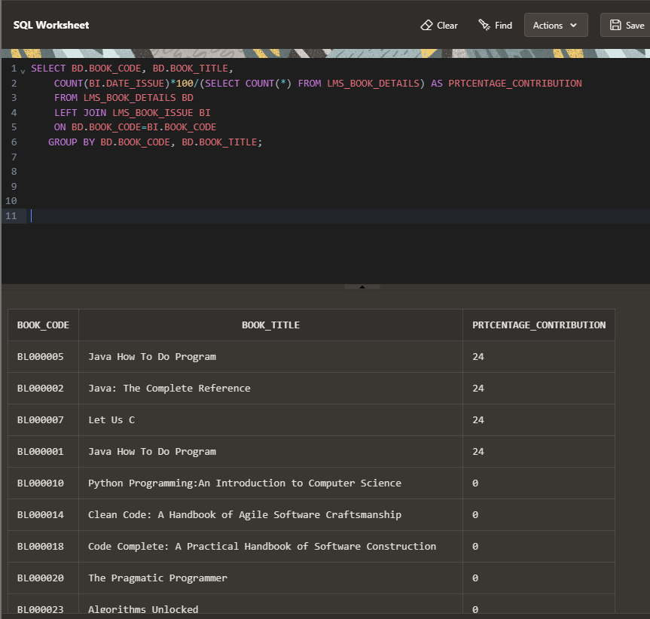

Explanation:

count the number of times each book has been issued and divide it by the total number of books

subquery is used to get the total number of books.

Q2) Find book name, member name, fine range for those members who paid fine (remove duplicates)

Ans.

SELECT BD.BOOK_TITLE, M.MEMBER_NAME, FD.FINE_RANGE

FROM LMS_BOOK_DETAILS BD

LEFT JOIN LMS_BOOK_ISSUE BI

ON BD.BOOK_CODE=BI.BOOK_CODE

LEFT JOIN LMS_MEMBERS M

ON BI.MEMBER_ID = M.MEMBER_ID

LEFT JOIN LMS_FINE_DETAIL FD

ON BI.ISSUE_ID = FD.ISSUE_ID

WHERE FD.FINE_RANGE IS NOT NULL

GROUP BY BD.BOOK_TITLE, M.MEMBER_NAME, FD.FINE_RANGE;

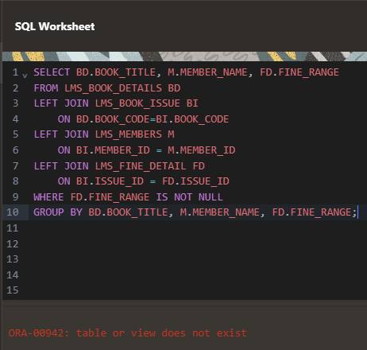

error

Attempt 2.

will join tables

SELECT * from LMS_BOOK_DETAILS; (book code)

SELECT * from LMS_BOOK_ISSUE; (book code, member id)

SELECT * from LMS_MEMBERS; (member id)

will use where and not having since 1.Before group by 2.need to filter rows

Ans.

SELECT BD.BOOK_TITLE, M.MEMBER_NAME, BI.FINE_RANGE

FROM lms_BOOK_DETAILS BD

LEFT JOIN LMS_BOOK_ISSUE BI

ON BD.BOOK_CODE=BI.BOOK_CODE

LEFT JOIN LMS_MEMBERS M

ON BI.MEMBER_ID=M.MEMBER_ID

WHERE BI.FINE_RANGE IS NOT NULL

GROUP BY BD.BOOK_TITLE, M.MEMBER_NAME, BI.FINE_RANGE;

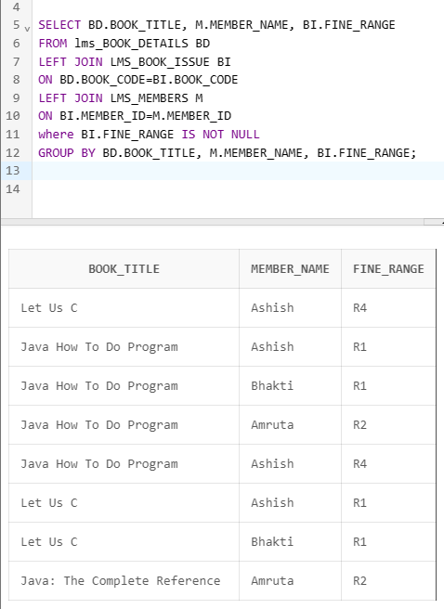

Q3) Create bucket based on fine paid or not.

Ans.

Method 1.

SELECT MEMBER_ID, DATE_RETURN,

CASE WHEN FINE_RANGE IS NULL THEN 'NOT PAID'

ELSE 'PAID'

END AS FINE_STATUS,

NTILE(2) OVER (

ORDER BY CASE WHEN FINE_RANGE IS NULL THEN 0 ELSE 1 END)

AS FINE_BUCKET

FROM LMS_BOOK_ISSUE;

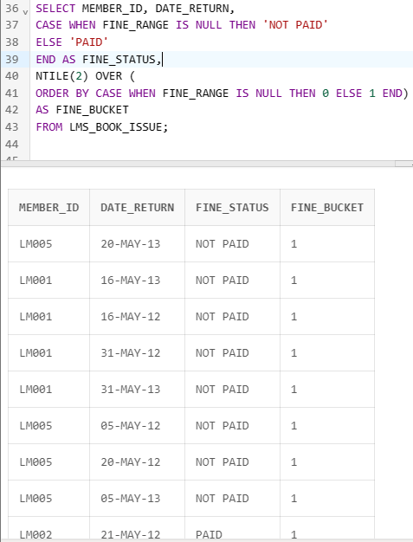

Method 2.

COALESCE function to replace NULL values with "NO".

SELECT MEMBER_ID, DATE_RETURN,

COALESCE(CASE WHEN FINE_RANGE IS NOT NULL THEN 'YES' END, 'NO') AS FINE_PAID

FROM LMS_BOOK_ISSUE

ORDER BY FINE_RANGE;

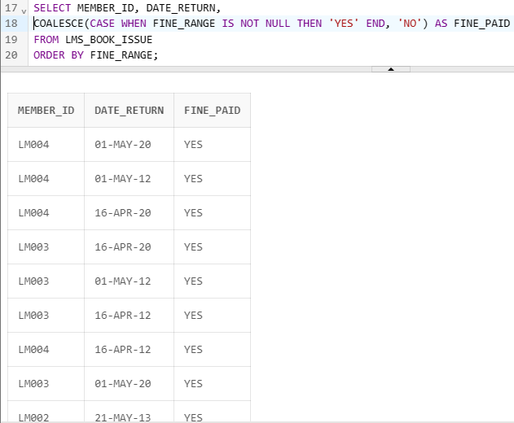

Method3.

SELECT MEMBER_ID, DATE_RETURN,

CASE WHEN FINE_RANGE IS NULL THEN 'NOT PAID'

ELSE 'PAID' END AS FINE_STATUS

FROM LMS_BOOK_ISSUE;

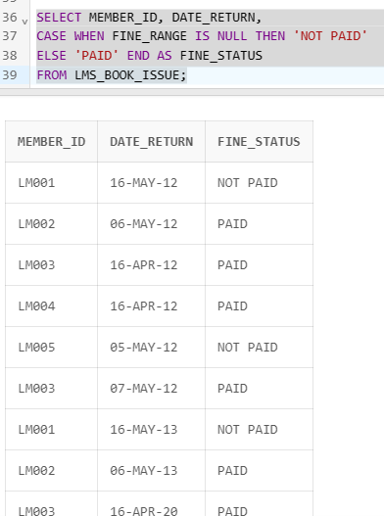

Q4) Find running total based on category of book issued

Ans-

Attempt 1.

SELECT BD.CATEGORY, BD.BOOK_TITLE, COUNT(BI.DATE_ISSUE) AS CATEGORY_ISSUE_COUNT

FROM LMS_BOOK_DETAILS BD

LEFT JOIN LMS_BOOK_ISSUE BI

ON BD.BOOK_CODE=BI.BOOK_CODE

WHERE BI.DATE_ISSUE IS NOT NULL

GROUP BY BD.CATEGORY, BD.BOOK_TITLE;

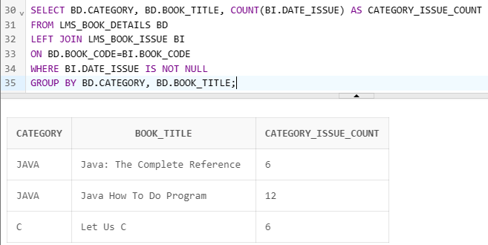

Attempt 2.

SELECT

CATEGORY,

BOOK_TITLE,

COUNT(DATE_ISSUE) AS CATEGORY_ISSUE_COUNT,

SUM(COUNT(DATE_ISSUE)) OVER (PARTITION BY CATEGORY ORDER BY BOOK_TITLE) AS RUNNING_TOTAL

FROM

LMS_BOOK_DETAILS

LEFT JOIN LMS_BOOK_ISSUE ON LMS_BOOK_DETAILS.BOOK_CODE = LMS_BOOK_ISSUE.BOOK_CODE

WHERE

DATE_ISSUE IS NOT NULL

GROUP BY

CATEGORY,

BOOK_TITLE

ORDER BY

CATEGORY,

BOOK_TITLE;

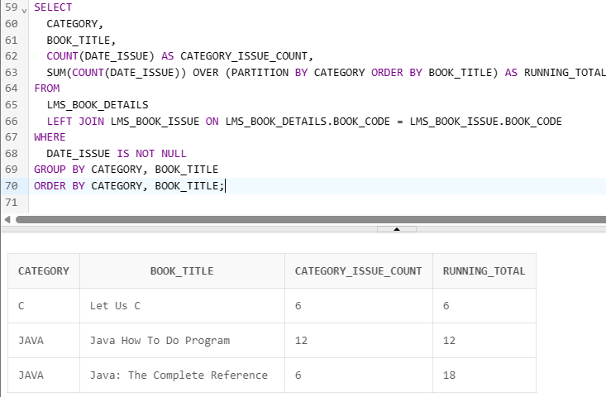

Q5) Find running total for fine paid

Attempt1.

SELECT

bi.BOOK_CODE,

fd.FINE_RANGE,

COUNT(fd.FINE_RANGE) as FINE_COUNT,

SUM(COUNT(fd.FINE_RANGE)) OVER (PARTITION BY bi.BOOK_CODE ORDER BY fd.FINE_AMOUNT) AS RUNNING_AMOUNT

FROM

LMS_BOOK_ISSUE BI

LEFT JOIN LMS_FINE_DETAILS FD ON BI.FINE_RANGE=FD.FINE_RANGE

WHERE BI.FINE_RANGE IS NOT NULL

GROUP BY bi.BOOK_CODE, fd.FINE_RANGE;

